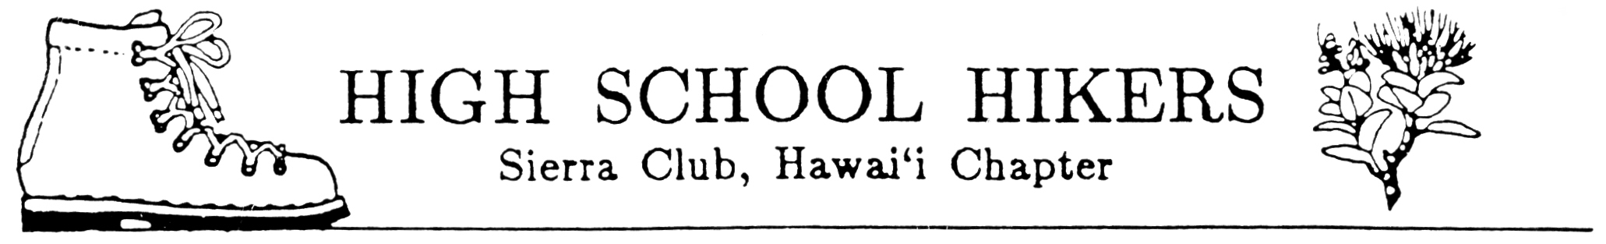
November 2, 2005

TO: All Club Advisors and Adult Members

FROM: Bob Keane and Fred Nakaguma, Ecology Camp Chairs
SUBJECT: Sierra Club High School Hikers’ Spring Trip to Kaua`i 2006

Get ready for our Spring Trip to Kauai 2006! It will be held on Kaua`i at the Discovery Center in Koke`e and Limahuli National Tropical Garden in Ha`ena. Attached are the registration forms. Please run off copies as needed and distribute to all hiking club members, adults and chaperones included. All attending the Spring Trip to Kaua`i 2006 must complete all forms.

The registration forms for students and chaperones consist of:
- Spring Trip Flier
- Spring Trip to Kaua`i (Tentative) Schedule
- General Information Form
- Guidelines for Student Behavior While Participating in the Spring Trip to Kauai 2006
- Registration Form
- Medical Information Form
- Minor Release Form
- Statement Concerning Swimming by Participant
- Statement of Understanding and Acceptance of Guidelines for Student Behavior (bottom of Swimming Form)

Additional sheets included in this package and for the advisors use include:
- Registration List

Reminders:
- Distribute materials to your students as soon as possible to inform parents/guardians. Consider having a “Parents Night” to answer any questions they may have and to work our club logistics. Be sure to receive your school’s approval of this activity by completing all forms, which are required, and purchasing student insurance for any uninsured participants.
- Each club will be allotted five (5) student slots and one advisor slot. Others will be placed on a waiting list. If additional slots are needed, let me know and I will inform you of space availability after forms from other clubs have been received.
- All advisors and adult members, including chaperones, must complete the health emergency form. These are to be turned in with all registration forms.
- Please make sure that all students attending the Spring Trip to Kaua`i understand that they will required to participate in all the service projects and they must provide their own work gloves.
- IMPORTANT DEADLINE: Final registration forms and checks must be received by March 2, 2006.

Mail to: Fred Nakaguma
99-524 Halawa Heights Road
Aiea, Hawaii 96701

- NO REFUNDS AFTER MARCH 17, 2006!

