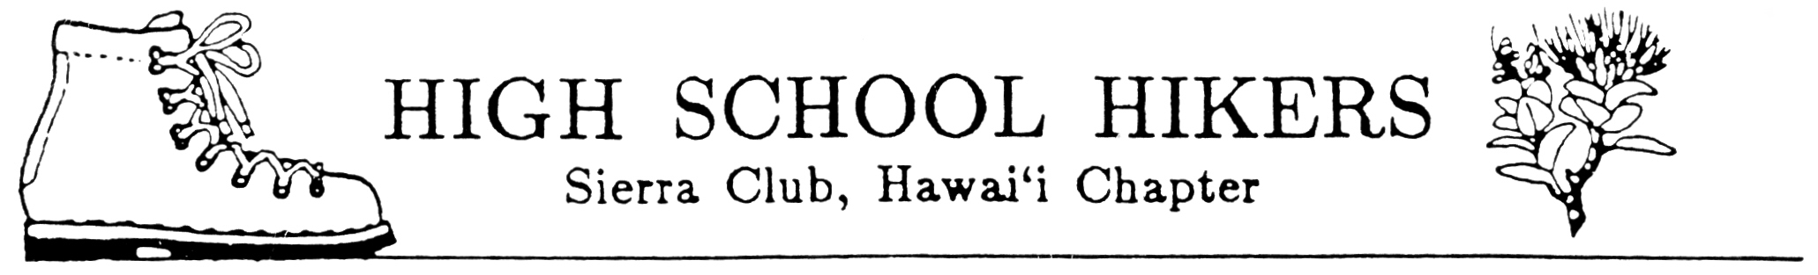

ECOLOGY CAMP 2012 - REGISTRATION FORM
OUR LADY OF KEA`AU
FEBRUARY 18-20, 2012

The High School Hikers Ecology Camp will be at Our Lady of Kea`au in Makaha. It is scheduled for the Presidents’ Day weekend, February 18-20, 2012. The registration fee covers food, T-shirt, and facilities use fee. In addition to our forms each student must complete a School Field Trip Permission form. Please complete all forms and make your check payable to your school’s hiking club. No refunds after January 31!

Name Sex Grade

School

Cost: $60

Circle size: S M L XL XXL

(Size must be submitted by January 10 in order to guarantee a shirt by camp)

Vegetarian? ______Yes

Each School Club Advisor will assign students to activities and service projects while at camp.

DEADLINE FOR ALL FORMS AND PAYMENT TO HIKING CLUB ADVISOR IS

(fill in)

NOTE: Deadline for all forms to Ecology Camp Registration Chair IS
January 10, 2012!

