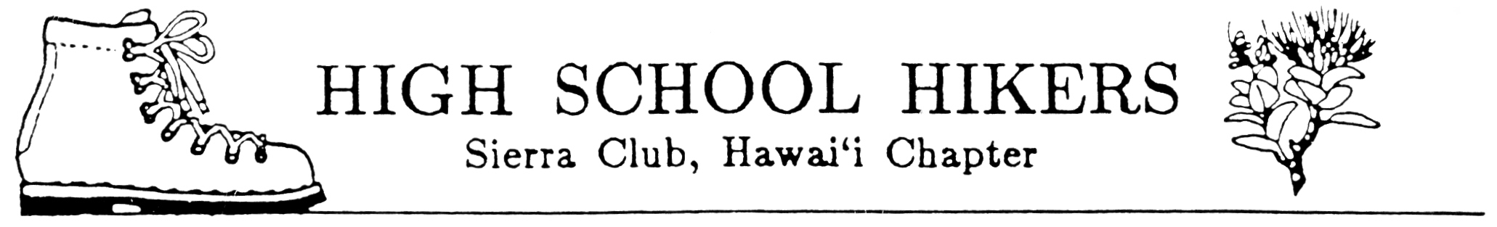

November 2011

TO: All Club Advisors and Adult Members

FROM: Pauline Kawamata, Ecology Camp Chair
SUBJECT: Ecology Camp 2012

The 2012 Ecology Camp will be held during Presidents’ Day weekend, February 18-20, 2012 at Our Lady of Kea‘au in Makaha. Attached are the general information flier and registration forms. Please run off copies as needed and distribute to hiking club members, adults and chaperones.

The registration forms for students, advisers and chaperones consist of:
- General Information Flier (includes tentative schedule)
- Guidelines for Student Behavior While Participating in Ecology Camp 2012
- **Registration Form
- **Sierra Club Release of Liability and Permission to Participate Form
- **Sierra Club Medical Form
- Sierra Club Medical Treatment and Authorization Form (Minor Release)
- Statement of Understanding and Acceptance of Guidelines for Student Behavior AND Statement Concerning Swimming by Participant Form (one form)

Additional sheets included in this package and for the advisors use include:
- **Sign-in Waiver Form
- Registration List
- Committees and Responsibilities List
- Our Lady of Kea‘au brochure

Reminders:
- Distribute materials to your students as soon as possible to inform parents/guardians. Consider having a “Parents Night” to answer any questions they may have and to work out club logistics. Be sure to receive your school’s approval of this activity by completing all forms, which are required, and purchasing student insurance for any uninsured participants.
- Each club will be allotted twelve (12) student slots. Others will be placed on a waiting list. If additional slots are needed, let me know and I will inform you of space availability after forms from other clubs have been received.
- All advisors and adult members, including chaperones, must complete the forms with asterisks. These are to be turned in with all registration forms.
- Please make sure that all students attending Ecology Camp understand that they will be required to participate in all activities and service projects and they must provide their own work gloves.
- IMPORTANT DEADLINE: Final registration forms and payments must be received by
JANUARY 10, 2012.
- NO REFUNDS AFTER JANUARY 31, 2012.

