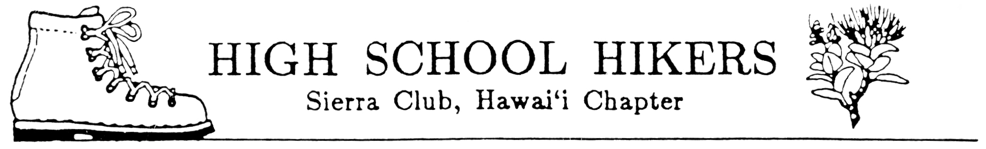
January 20007

TO: All Club Advisors and Adult Members

FROM: Bob Keane and Fred Nakaguma, Ecology Camp Chairs
SUBJECT: Sierra Club High School Hikers’ Ecology Camp 2007

Get ready for Ecology Camp 2007! It will be at held at campsites in Malaekahana State Park located between Kahuku and La`ie. Attached are the registration forms. Please run off copies as needed and distribute to all hiking club members, adults and chaperones included. All attending Ecology Camp 2007 must complete all forms.

The registration forms for students and chaperones consist of:
- General Information Form
- Ecology Camp Schedule (THIS SCHEDULE WILL BE EMAILED TO ADVISORS AT A LATER DATE.)
- Guidelines for Student Behavior While Participating in Ecology Camp 2007
- Registration Form
- Statement of Understanding and Acceptance of Guidelines for Student Behavior (bottom of Registration Form)
- Individual Liability Form
- Statement Concerning Swimming by Participant
- Medical Information Form (2 pages)

Additional sheets included in this package and for the advisors use include:
- Registration List
- Committees List (emailed to advisors mid-January 2007)

Reminders:
- Distribute materials to your students as soon as possible to inform parents/guardians. Consider having a “Parents Night” to answer any questions they may have and to work our club logistics. Be sure to receive your school’s approval of this activity by completing all forms, which are REQUIRED, and purchasing student insurance for any uninsured participants.
- Each club will be allotted 10 student slots. Others will be placed on a waiting list. If additional slots are needed, advisors will be informed of space availability after forms from other clubs have been received.
- All advisors and adult members, including chaperones, must complete the health emergency form. These are to be turned in with all registration forms.
- Please make sure that all students attending Ecology Camp understand that they will required to participate in the all day service project and they must provide their own work gloves.
5. IMPORTANT DEADLINE: All registration forms must be received by January 31, 2007. Checks can be submitted at the HSH meeting on February 6. NO REFUNDS AFTER FEBRUARY 10, 2007!
6. Mail to: Pauline Kawamata
Hawaii Nature Center
2131 Makiki Heights Dr.
Honolulu, HI 96822

