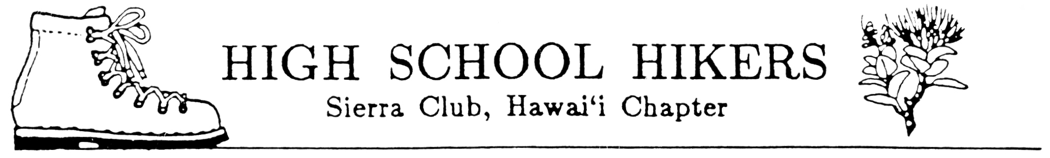
ECOLOGY CAMP AND FALL HIKERS WORKSHOP 2007
REGISTRATION FORM
OUR LADY OF KEA`AU
NOVEMBER 10-12, 2007

The High School Hikers Ecology Camp and Fall Hikers Workshop will be at Our Lady of Kea`au in Makaha. It is scheduled for the Veterans' Day weekend, November 10-12, 2007. The registration fee covers food, T-shirt, and facilities use fee. In addition to our forms each student must complete a School Field Trip Permission form. Please complete all forms and make your check payable to your school’s hiking club. No refunds after October 31!

Name Sex Grade

School

Cost: $50 (includes T-shirt)

Circle size: S M L XL XXL
(Size must be submitted by October 23 in order to guarantee a shirt by camp)

Vegetarian? ______Yes

Each School Club Advisor will assign students to activities and service projects while at camp.

DEADLINE FOR ALL FORMS AND PAYMENT TO HIKING CLUB ADVISOR IS

(fill in)

NOTE: Deadline for all forms to Ecology Camp Registration Chair IS
October 23, 2007!

STATEMENT OF UNDERSTANDING AND ACCEPTANCE
OF GUIDELINES FOR STUDENT BEHAVIOR WHILE PARTICIPATING IN
ECOLOGY CAMP AND FALL HIKERS WORKSHOP 2007

We have reviewed the “Guidelines for Student Behavior While Participating in Ecology Camp and Fall Hikers Workshop 2007” and agree to uphold them.

____________________________________________ Date ____________________
(Student’s Signature)

___________________________________________ Date ____________________
(Parent’s/Guardian’s Signature)

