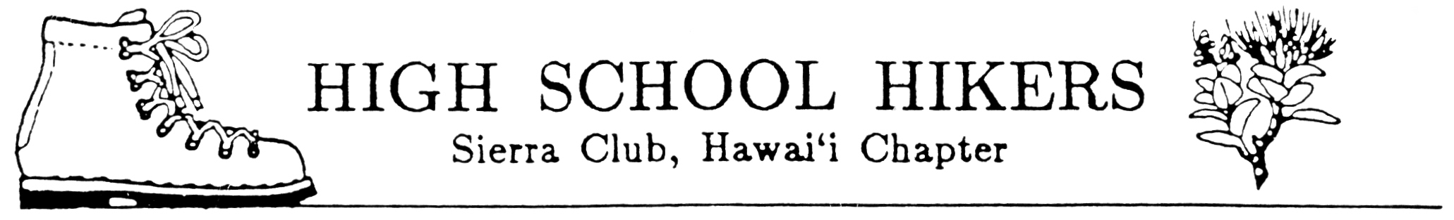
August 2007

TO: All Club Advisors and Adult Members

FROM: Pauline Kawamata, Ecology Camp Chair
SUBJECT: High School Hikers’ Ecology Camp & Fall Hikers Workshop 2007

Get ready for Ecology Camp and Fall Hikers Workshop 2007! It will be at held at Our Lady of Kea`au in Makaha. Attached are the general information flier and registration forms. Please run off copies as needed and distribute to all hiking club members, adults and chaperones.

The registration forms for students and chaperones consist of:
- General Information Flier (includes the camp schedule)
- Guidelines for Student Behavior While Participating in Ecology Camp & Fall Hikers Workshop 2007
- Registration Form
- Statement of Understanding and Acceptance of Guidelines for Student Behavior (bottom of Registration Form)
- Individual Liability Form
- Statement Concerning Swimming by Participant
- Medical Information Form (2 pages)

Additional sheets included in this package and for the advisors use include:
- Registration List
- Committees List (final list will distributed to advisors by the end of August)
- Our Lady of Kea`au brochure

Reminders:
- Distribute materials to your students as soon as possible to inform parents/guardians. Consider having a “Parents Night” to answer any questions they may have and to work our club logistics. Be sure to receive your school’s approval of this activity by completing all forms, which are REQUIRED.
- Each club will be allotted 10 student slots. Others will be placed on a waiting list. If additional slots are needed, advisors will be informed of space availability based on the timely receipt of registration forms by each club.
3. All students attending camp must complete ALL FORMS. All advisors and adult members, including chaperones, must complete the following three forms: registration, individual liability, and medical information. These are to be turned in with all registration forms.
4. Please make sure that all students attending this event understand that they will required to participate in all the service projects and they must provide their own work gloves.
5. IMPORTANT DEADLINES:
► All registration forms must be received by MONDAY, OCTOBER 23.
► Checks can be submitted at the HSH meeting on Thursday, November 1.
► NO REFUNDS AFTER OCTOBER 31, 2007!
6. Mail to: Pauline Kawamata
Hawaii Nature Center
2131 Makiki Heights Dr.
Honolulu, HI 96822

