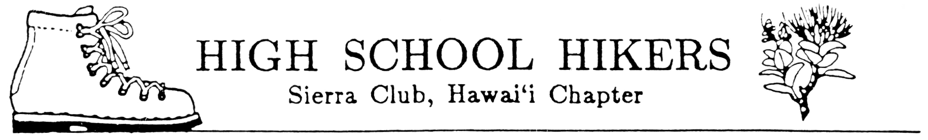
August 2004

TO: All Club Advisors and Adult Members

FROM: Bob Keane and Fred Nakaguma, Ecology Camp Chairs
SUBJECT: Sierra Club High School Hikers’ Advanced Ecology Camp 2005

Get ready for Advanced Ecology Camp 2005! It will be a six-day trip to Moloak`i and planning is nearly complete. Attached are the registration forms. Please run off copies as needed and distribute to all hiking club members, adults and chaperones included. All attending Ecology Camp 2005 must complete all forms.

The registration forms for students and chaperones consist of:
- Ecology Camp Flier
- Ecology Camp (Tentative) Schedule
- General Information Form
- Guidelines for Student Behavior While Participating in Ecology Camp 2005
- Registration and Student Payment Form
- Statement Concerning Swimming by Participant and Statement of Understanding and Acceptance of Guidelines for Student Behavior
- Individual Liability Form
- Medical Information Form

Additional sheets included in this package and for the advisors use include:
- Registration List
- Committees List

Reminders:
- Distribute materials to your students as soon as possible to inform parents/guardians. Consider having a “Parents Night” to answer any questions they may have and to work our club logistics. Be sure to receive your school’s approval of this activity by completing all forms, which are required, and purchasing student insurance for any uninsured participants.
- Each club will be allotted six (6) student slots and one advisor slot. Others will be placed on a waiting list. If additional slots are needed, let me know and I will inform you of space availability after forms from other clubs have been received.
- All advisors and adult members, including chaperones, must complete the health emergency form. These are to be turned in with all registration forms.
- Please make sure that all students attending Ecology Camp understand that they will required to participate in the all day service project on Sunday and they must provide their own work gloves.
- IMPORTANT DEADLINE: All registration forms and checks must be received by January 23, 2005.

Mail to: Pauline Kawamata
Hawaii Nature Center
2131 Makiki Heights Dr.
Honolulu, HI 96822

6. NO REFUNDS AFTER JANUARY 31, 2004!

