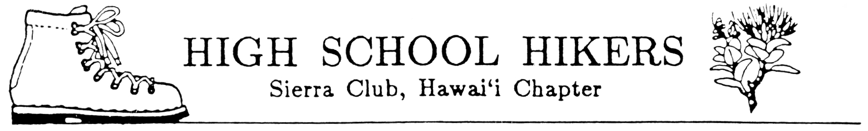
ECOLOGY CAMP 2004
CAMP PUPUKEA
February 14-16, 2004
(as of 10/3/03)

Time Activity Activity Leader

Saturday, Feb. 14, 2004:

9:00 -10:30 AM Camp registration and setting assigning tents.

10:30-11:30 AM Orientation and Ice breakers at Campfire Bowl.

11:30 AM-12:30 PM Brown Bag Lunch

12:30-4:00 PM Workshops and "Cope Course" Fred Nakaguma/Bob Keane
(7 events low ropes course)
Workshops TBA

4:00-5:00 PM Pool Party /Mark Lee

5:00-6:00 PM Clean up and prepare for dinner

6:30-7:00 PM Dinner, Weinberg Lodge Nylen Takahashi/Darryl Nishimoto

7:00-8:30 PM Evening Program, Weinberg Lodge Fred Nakaguma/Bob Keane

Guest Speaker: Kelly Perry, Volunteer Coordinator
Topic: Waimea Falls Park

Bat ('ope'ape'a) Locating: Kim Welch, Waimea Falls Park

Night insect Collecting: Steve Montgomery

9:00-10:00 PM Campfire Activities and Snack Nylen Takahashi/Darryl Nishimoto
Campfire Bowl

11:00 PM Lights out

Sunday, Feb. 15, 2004:

6:00 AM Wake Up

6:30 -7:30 AM Breakfast, Weinberg Lodge Nylen Takahashi/Darryl Nishimoto

8:00 AM Depart for Waimea Valley Audubon Center Fred Nakaguma/Bob Keane
and organize for service projects

9:00 -11:30 AM Service projects Fred Nakaguma/Bob Keane

11:30 AM-12:30 PM Lunch Nylen Takahashi/Darryl Nishimoto

12:30-3:00 PM Service projects Fred Nakaguma/Bob Keane

3:00 PM-4:00 PM Swimming at Waihe'e Falls (Waimea Falls) Mark Lee

4:30 PM Depart Waimea Valley Audubon Center

6:00-7:00 PM Dinner, Weinberg Lodge Nylen Takahashi/Darryl Nishimoto

7:30-9:00 PM Dance Erron Yoshioka
Weinberg Lodge

9:00-10:00 PM Campfire Activities and Snack Nylen Takahashi/Darryl Nishimoto
Campfire Bowl

11:00 PM Lights out

Monday, Feb. 16, 2004:

7:00 -8:00 AM Breakfast, Weinberg Lodge Nylen Takahashi/Darryl Nishimoto

8:00-9:00 AM Break down camp/Clean up

9:00-10:00 AM Final Activities/Camp Evaluation

10:00-12:00 AM Depart Camp Pupukea

